Worldpay and E2Pay practical payment validation
Validation date 9 October 2026
Decision pending merchant and provider confirmation. Sandbox payment success, controlled decline and abandonment recovery are documented. Live payment readiness is not established.

Requirement status
Requirement | Status | Evidence
Worldpay product and sandbox | Done | E1, S8, S11
Intended E2Pay and eligibility | Blocked | S2 to S7
US availability and USD | Partly done | E5, S11
Unique reference and hosted checkout | Done | E5
Successful sandbox payment | Done | E5, E9
Controlled decline in the app | Done | E6
Abandonment and expiry recovery | Done | E3
Browser double click | Done | E2
Eight concurrent create calls | Partly done | E7
Return replay and refresh | Done | E4
Genuine notification and replay | Blocked | E8
Transaction and currency evidence | Partly done | E5, E9
Portal charge count screenshot | Blocked | E9 API only
Late payment and actual outage | Not done | Not run
Outstanding authorization | Blocked | E10
Successful refund | Blocked | E11
Settlement and dispute exercise | Not done | S14, proposals
Production approval and live claim | Blocked | No approval
Outreach drafts | Done | E12, not sent
Tests and disposable user cleanup | Done | E13, E14

Decision and scope
Worldpay Express Hosted Payments is a working sandbox candidate. Browser payment success, controlled decline and abandoned checkout recovery were tested. These prove sandbox behavior. They do not establish production approval or live settlement. E2Pay remains blocked until Mr Saad identifies the intended provider and that provider confirms US eligibility and USD charging and settlement.
Recommendation: decision pending merchant and provider confirmation. Continue Worldpay validation while keeping the shared payment interface. Neither provider is ready for an unconditional live payment claim under the assigned requirements.

Identify E2Pay first
The researched candidate is PT E2Pay Global Utama in Indonesia, identified by Fiuu as an acquired business. This is not yet confirmed as the E2Pay intended by Mr Saad. The similarly named e2pay.org website shown in Figure 3 is not identity evidence for this candidate. [2]
Required information | Current finding
Company and official website | Candidate: PT E2Pay Global Utama. Fiuu contact page lists the entity. www.e2pay.co.id is the candidate website. Intended provider still needs confirmation. [2, 3]
US processing and USD | US merchant acceptance and USD charging and settlement are not confirmed. The reviewed Direct API explicitly specifies IDR (Indonesian Rupee) only. This does not establish the capabilities of every product. [7]
API and hosted checkout | Candidate documentation is available at e2payprod.gitbook.io. Hosted checkout and a sandbox endpoint are documented. [4, 5]
Callbacks and verification | Candidate documentation describes Notify and Callback routes plus payment queries. No integration was tested. Merchant eligibility, signing configuration and duplicate event behavior require confirmation. [6, 7]
Sandbox account | Not obtained. A login portal was found; the screenshots do not prove that signup is impossible. Request the correct test merchant and credentials from integration support. [4]
Onboarding and support | Exact merchant checklist and approval timing not confirmed. Candidate technical contact: integration@e2pay.co.id. Fiuu also lists merchant support and refund or dispute contact routes. [3, 4]

Minimum action required from Mr Saad
Confirm the legal company name, official URL and existing sales or merchant contact. If the Indonesian candidate is intended, ask integration support for written US and USD eligibility, the exact merchant document checklist, sandbox MerchantID or MerchantCode, signing keys, test cards, endpoint documentation and an approval owner. No request submission or approval date is evidenced. We cannot promise access by Friday.

Worldpay product and sandbox access
The implemented product is Worldpay Express XML with Express Hosted Payments and the Reporting API. Worldpay Integrated Payments, LLC is named in the Express specification. This is distinct from Access Worldpay and its Hosted Payment Pages product. Express is the product actually exercised here; the chosen US merchant account must be provisioned for it. [8, 10]
Sandbox status: obtained. We created a Worldpay account and used hosted payment credentials. Figures 4 to 7 show the signup and developer dashboard. Figures 9 to 13 show hosted checkout and registration confirmation. No merchant or implementation manager approval was needed for the test access used here. That does not establish the route for production approval or every Worldpay product.

Credentials and approval dependency
Express requires AccountID, AccountToken, AcceptorID and ApplicationID. These map to the four WORLDPAY_HOSTED_PAYMENTS environment values. The test environment uses the certification transaction and reporting endpoints. Production requires approved live merchant credentials, the assigned terminal settings and confirmation that Express supports this US online league business and its USD bank settlement. No production approval is evidenced. [8]

Implementation location and provider selection
Repository: https://github.com/zaidasim-sd/atlanta-tennis-connect/tree/worldpay. The implementation, report and referenced evidence are published on the worldpay branch in commit 0abce1d09417f66dc615667f05d341a6e2a11fe5. Sandbox tests used a separate disposable database. [1]
PAYMENT_PROVIDER selects mock, stripe or worldpay. The selected adapter is constructed through the shared PaymentProvider interface. Worldpay uses worldpayProvider.ts and worldpayPayment.ts in backend/src/payment, reservationService.ts in backend/src/lib, and the Worldpay checkout component in src/components. Existing reservations retain their provider; finish them before switching environments.

Flow implemented
The backend creates a pending reservation with a 15 minute capacity hold and uses its identifier as the unique order reference. A durable session claim prevents concurrent creation of multiple hosted sessions. Card entry occurs on Worldpay. Before registration confirmation, authenticated Reporting checks the order reference, amount and merchant identifiers when supplied. Returned currency is checked when present. Capture TransactionID is saved separately from authorization TransactionID. A browser return alone cannot confirm payment.
Hosted checkout expires after 10 minutes. Reservations hold capacity for 15 minutes. Checkout closure and Reporting must show no live authorization before capacity is released. Unresolved state deliberately retains capacity beyond the deadline. This differs from the brief's unconditional release rule on purpose, to prevent a charge after a spot has been sold again. The decline and abandonment tests safely released capacity. [8, 11]

Hosted checkout versus direct card entry
Hosted checkout is recommended for V1. Worldpay collects the card fields. The tennis application does not receive raw card numbers or CVV in this flow. Direct card entry would expand the card handling scope. Hosted checkout reduces PCI exposure, but the merchant must confirm its required PCI validation, secure its website and access, prevent card data in logs, and manage refunds and disputes. Hosting does not remove those responsibilities. [8, 11, 14]
The browser return checks TransactionSetupID and ValidationCode, followed by authenticated Reporting. This is not a server webhook. The reviewed Express documentation gives no server notification route, signing configuration or delivery contract for this account. Worldpay must confirm whether an optional route exists. Access Events documents server webhooks but needs implementation manager provisioning and does not establish Express compatibility. No notification was captured or fabricated. [8, 11, 13]

Practical evidence and test results
The screenshots cover provider access, hosted checkout, registration, success, decline, abandonment, double click and refresh. Browser tests were recorded on 8 and 9 October 2026. Sensitive fields are redacted. Raw provider evidence is parsed XML with fields outside the allowlist redacted. It is not a byte for byte XML copy. Test results use saved files and are not portal charge counts.

Actual sandbox records
Authenticated Reporting queries identified the records below, including capture 674877825 linked to authorization 674877822 for order ending 709a3ae5. Completed authorization indicates provider reported capture completion, not bank settlement. USD below is the merchant configured currency; observed Reporting data did not independently return currency.
Order suffix and USD | Worldpay transaction evidence | App result
709a3ae5 35.00 | 674877821 Declined, code 2; 674877822 AuthCompleted, code 6. Linked capture: 674877825. | registered  paidAt 06:27:55 UTC
0f923253 40.00 | 674877186 and 674877189 Declined  674877238 AuthCompleted, code 6 | registered  paidAt 06:12:44 UTC
709a38e3 40.00 | 674877436 Authorized, code 5 | payment_pending  No paidAt value

Authorization 674877436 remained Authorized in the 9 October state check. Its reversal retry on 8 October at 12:41 UTC returned code 20, Declined. Further attempts were stopped. Capacity remains held and the reservation is unconfirmed. No extra reversal or refund was submitted. [E10]

Tests completed and evidence limits
Case | Result and evidence
Hosted checkout and success | 3500 cent payment approved on 9 October. One confirmed registration and capture 674988144. Numbered screenshots and E5, E9.
Decline or failure | Documented 257 cent decline. Authorization 674988272 is Declined. Reservation failed, confirmed count zero and capacity restored to 10. E6 and decline figures.
Unique reference and refresh | Unique order references are saved. Three browser refreshes and two hosted return verifier replays preserved one registration, capture 674988144 and capacity 9. E4, E9.
Double submission | Actual browser double click produced one checkout. Eight authenticated HTTP requests produced one reservation and setup. Six returned 201, two returned 500. No second setup. E2, E7.
Ambiguous creation | Automated test blocks a new payable session after a timeout. Manual recovery still required.
Authorization and capture | Authorization 674988139 is AuthCompleted. Separate capture 674988144 is Approved. One capture is found by reference query. E5, E9.
Cancellation and abandonment | Abandoned checkout expired after no payment. Reporting found no transaction and capacity returned from held 9 to 10. Decline also released safely. Late payment was not run. E3, E6.
Webhook and duplicate events | The hosted return verifier was replayed twice. No genuine server notification was available or tested. Reporting replay is not notification replay. E4, E8.
Refund and amount checks | Automated amount and returned currency checks pass. Refund rejection was reported, but its raw output is missing. No successful refund is verified. E11, E13.
Provider isolation and code 90 | Automated tests confirm selected adapter only. Reporting No Record(s) is treated as pending only in the exact query context.

The backend payment and authentication suite passed 45 tests. The supplementary backend unit suite passed 7 tests. All 52 tests passed with zero failures, skips or cancellations. Frontend and API TypeScript checks passed. A regression test verifies that browser supplied confirmation cannot create or change a registration. CORS tests accept configured origins and reject unrelated sites. Actual sandbox evidence and automated tests are labelled separately. [E13]

What must happen before a live payment claim

Engineering acceptance gates
1. Resolve the genuine server notification requirement. No provider event was captured. Express browser return verification and Reporting polling are not verified webhook evidence. Worldpay must confirm and provision the route or a suitable product. [E8]
2. Durable transaction evidence is implemented. Amount, reference, reservation, provider status, event time and verification time are recorded. Capture IDs are separate. Observed Reporting data still supplies no currency field. USD is merchant configuration, labelled merchant_configuration, and does not meet independent provider currency verification. Confirm USD presentment and settlement with the approved merchant account. [E5, E9]
3. Success, controlled decline, abandonment, double click, return replay and refresh have saved results. Eight concurrent HTTP create calls produced one reservation and setup, but two requests failed while creation was unresolved. The unpaid setup had no Reporting charge record. Genuine duplicate notification, portal counts and late payment remain open. [E2, E3, E4, E5, E6, E7, E9]
4. Authorization 674877436 remains unresolved after a declined reversal retry. Capacity stays held. The decline and abandoned checkout safely released their holds. Automated outage recovery passes. A controlled actual outage and late payment exercise were not run. [E3, E6, E10, E13]
5. No successful refund is verified. A 100 cent return for capture 674877825 was reported as rejected with code 103. Its raw output file is empty, so that response remains unverified. The stored refund operation is pending. Obtain provider resolution and successful Reporting and portal evidence. Settlement and dispute procedures below are proposals, not completed tests. [E11]

Merchant approval and production validation
Mr Saad or the authorized merchant owner must confirm the legal entity, obtain the Worldpay onboarding checklist and submit the requested business, ownership, identity, website and settlement bank information. Exact documents, review timing, pricing, reserves and certification requirements remain provider decisions. The team needs live AccountID, AccountToken, AcceptorID, ApplicationID, assigned terminal details and written US and USD approval before switching to production.
After engineering and merchant approval, perform one authorized low value live payment, match the provider transaction and registration, verify settlement to the approved bank account and test the agreed refund process. Only then state that live payments and settlement have been validated. Sandbox success cannot establish live settlement.

Refunds chargebacks settlement and disputes
The Express specification documents CreditCardReturn, CreditCardReversal, CreditCardVoid, authorization completion and batch methods. The Hosted Payments page excludes unlinked refunds. These documented methods do not establish entitlement or successful execution for this account. Worldpay's merchant support page links transaction history, settlement details and chargeback resources. Account funding terms, fees, reserves and response deadlines remain unconfirmed. No bank settlement or dispute was tested. [8, 11, 14]
Proposed settlement procedure, not tested: obtain the assigned batch and settlement reports. Match capture IDs, order references, amounts, refunds and totals to the local ledger and bank deposit. Investigate differences. Worldpay must confirm the available reports, funding terms and account access before this can become an approved operating procedure.
Proposed dispute procedure, not tested: monitor the approved provider channel. Record the reference, capture ID, amount, reason and provider deadline. Preserve registration evidence and respond through the authorized portal. Reconcile the final adjustment. Do not invent a contractual deadline or release capacity from an unverified notice.
For the E2Pay candidate, the reviewed material describes hosted checkout, notifications and a test endpoint. Its Direct API specifies IDR. Fiuu publishes transaction, refund and dispute contact routes. None of this confirms US eligibility, USD settlement or refund API entitlement for the Atlanta operator. No E2Pay integration or merchant account was tested. [3, 5, 6, 7]

Evidence retained
Saved evidence is under docs/evidence. The status note lists exact filenames for E1 to E14. Browser screenshots are under docs/evidence/screenshots and are included as numbered figures. Outreach drafts are under docs/outreach and were not sent. Both disposable users and their database were removed after evidence capture. Provider sandbox transaction records remain. No test access path was added. [E12, E14]

Sandbox test results
Controlled decline: order 6ac8701dd322b225fc340675 used the official Express test card and 257 cent trigger. The hosted page returned Declined. Reporting records authorization 674988272 with transaction status code 2. The app marked the reservation failed, left it unconfirmed and restored capacity to 10. The fee was changed only in the disposable test league. [12, E6]
Abandonment: order 6ac78e559a3e1e883801d9cf reached a blank hosted form and was closed without payment on 8 October at 12:36:53 UTC. Its hold deadline was 12:51:37 UTC. Reconciliation ran on 9 October at 04:28 UTC after the hold deadline. Reporting found no transaction. The reservation expired and held capacity 9 returned to 10. This does not prove release exactly at the deadline. [E3]
Success: order 6ac86f32d322b225fc3404e3 completed a 3500 cent payment. Authorization 674988139 is AuthCompleted and capture 674988144 is Approved. The app had one confirmed registration and capacity 9. The hosted return verifier was replayed twice, reconciliation ran twice and the page was refreshed three times. One registration, one capture ID and capacity 9 remained. No video was recorded because the available browser tool has no video recording API. [E4, E5, E9]
Double submission: the browser double click created one checkout for order 6ac78f769a3e1e883801daa6. Eight adapter calls reused it. A separate eight request HTTP run created one reservation and setup for order 6ac8712dd322b225fc340789. Six requests returned 201 and two returned 500 while creation was unresolved. Capacity changed from 10 to 9 and returned to 10 after verified cancellation. This protects against a second session but leaves a request reliability gap. [E2, E7]
An unpaid hosted setup has no Reporting charge record. For the paid success order, two Reporting rows are one authorization and one capture. The approved capture count is one. These are authenticated API records, not portal screenshots. Portal completeness and bank settlement remain unverified. No portal account email or authenticated portal access was available. [E9]
Confirmation safeguard: the browser supplied confirmation endpoint is disabled with HTTP 410. It cannot create a paid registration. A regression test and real local HTTP check verify this. The shared PaymentProvider interface is unchanged. A remaining frontend call to that obsolete endpoint ignores its response but can no longer change server records. Its removal and general success error handling remain follow up work. [E13]
Cleanup: both disposable users, their sessions and the dedicated test database were removed after evidence capture. Five test leagues and five test reservations were removed. Original application data was not deleted or reset. The provider sandbox transactions remain. No test access path was added. The local test servers and temporary card input material were removed or stopped. [E14]
Scenario | Reporting rows | Approved captures | Confirmed app entries
Abandonment | 0 | 0 | 0
Decline | 1 | 0 | 0
Double click | 0 | 0 | 0
HTTP concurrency | 0 | 0 | 0
Success | 2 | 1 | 1

Saved evidence references
E1 worldpay-run-manifest-2026-10-09.json
E2 2026-10-08T124134089Z-concurrent.json and double click screenshots
E3 2026-10-09T042800611Z-job.json and abandonment screenshots
E4 2026-10-09T043822571Z-replay.json and refresh screenshots
E5 2026-10-09T043718677Z-snapshot.json and numbered success screenshots
E6 2026-10-09T044300429Z-snapshot.json and decline screenshots
E7 2026-10-09T044424800Z-http-concurrent.json
E8 worldpay-callback-findings-2026-10-09.md and official page screenshots
E9 2026-10-09T045201384Z-reports.json, authenticated API only
E10 2026-10-08T124109681Z-reverse.json and 2026-10-09-original-state-check.json
E11 Reported refund rejection is unverified because raw output is empty. The stored operation is pending. No successful refund is verified.
E12 docs/outreach contains three drafts. None was sent or submitted.
E13 2026-10-09-final-backend.txt, 2026-10-09-final-backend-unit.txt, 2026-10-09-final-typescript.txt and confirmation route check JSON
E14 2026-10-09-cleanup.json

Sources and provider contacts
Official links and saved evidence were checked on 8 and 9 October 2026. Sources have unique numbers. Candidate E2Pay material does not establish the intended provider or US merchant approval.
1 Proof of concept repository and worldpay branch
2 Fiuu identifies PT E2Pay Global Utama
3 Fiuu official contact and Indonesia support routes
4 E2Pay candidate documentation and integration support
5 E2Pay candidate hosted checkout and sandbox path
6 E2Pay candidate notification and query flow
7 E2Pay candidate Direct API and IDR restriction
8 Worldpay Express Interface Specification
9 Worldpay developer dashboard
10 Published Worldpay merchant agreement, not proof of this account terms
11 Worldpay Express Hosted Payments
12 Official Express test cards and triggers
13 Access Events provisioning and verification
14 Worldpay US merchant support

E2Pay next action and owner
Owner: Mr Saad confirms the intended company, website and merchant contact. The E2Pay and Fiuu inquiries are saved as drafts only. No send date or submission date is recorded. Provider answers must establish US eligibility, USD charging and settlement, the merchant checklist and usable test credentials before integration starts. [E12]

Worldpay next action and owner
Owner: the developer completes the remaining evidence and notification work once provisioned. Mr Saad or the authorized merchant owner obtains production approval and asks Worldpay implementation support to confirm the product, server notification route, USD configuration, reversal and refund entitlements, settlement reports and dispute access. The support message is a draft only. [E8, E10, E11, E12]

Screenshot interpretation
The figures show provider access and the application payment workflow. Browser address rows, sensitive fields and the card fields in Figure 10 are redacted. Figures 14 and 15 do not prove duplicate charge prevention. Provider results and registration counts are recorded separately.

Screenshot evidence

Figure 1 Fiuu contact form
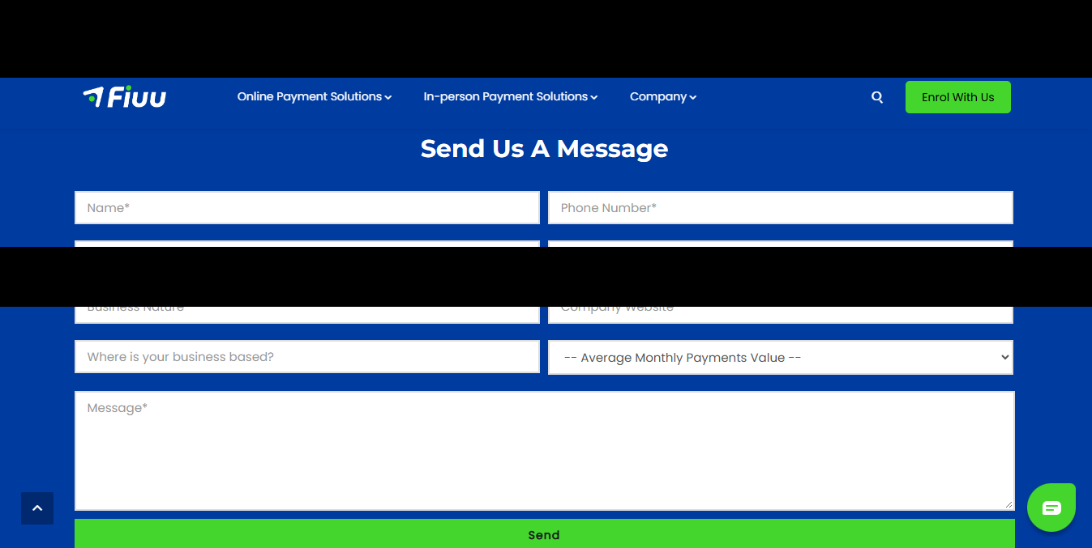
A contact route was located. The screenshot does not show a submitted inquiry or approval.

Figure 2 E2Pay sandbox portal
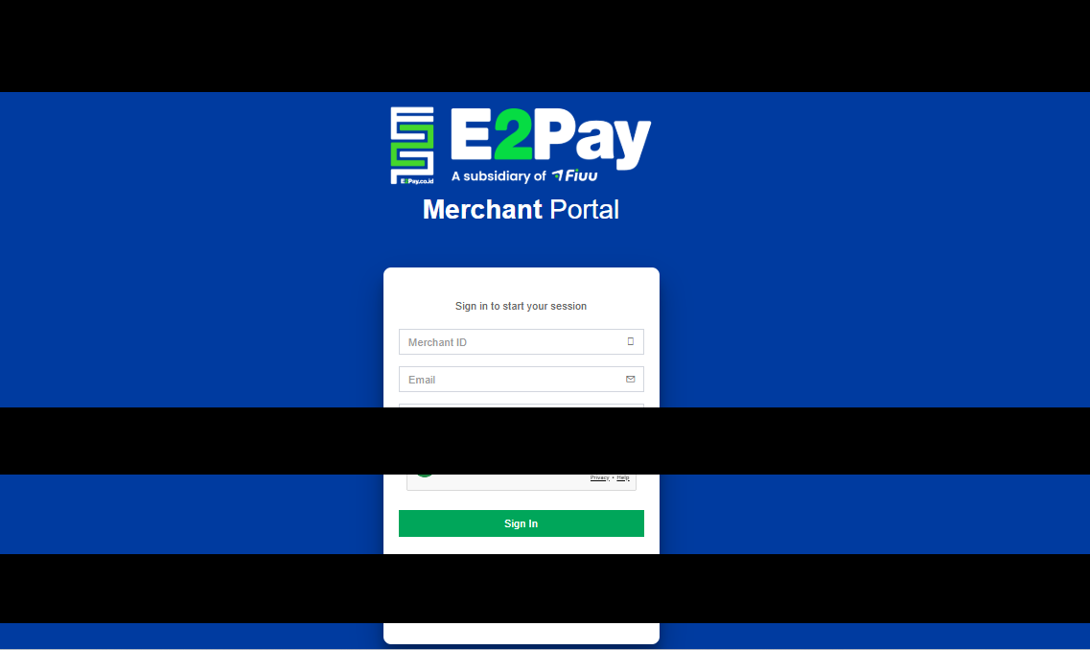
The portal requires a merchant login. Test credentials were not obtained.

Screenshot evidence

Figure 3 Similarly named website

The e2pay.org page is preserved as a research observation. It is not evidence of the intended company or gateway.

Figure 4 Worldpay developer signup
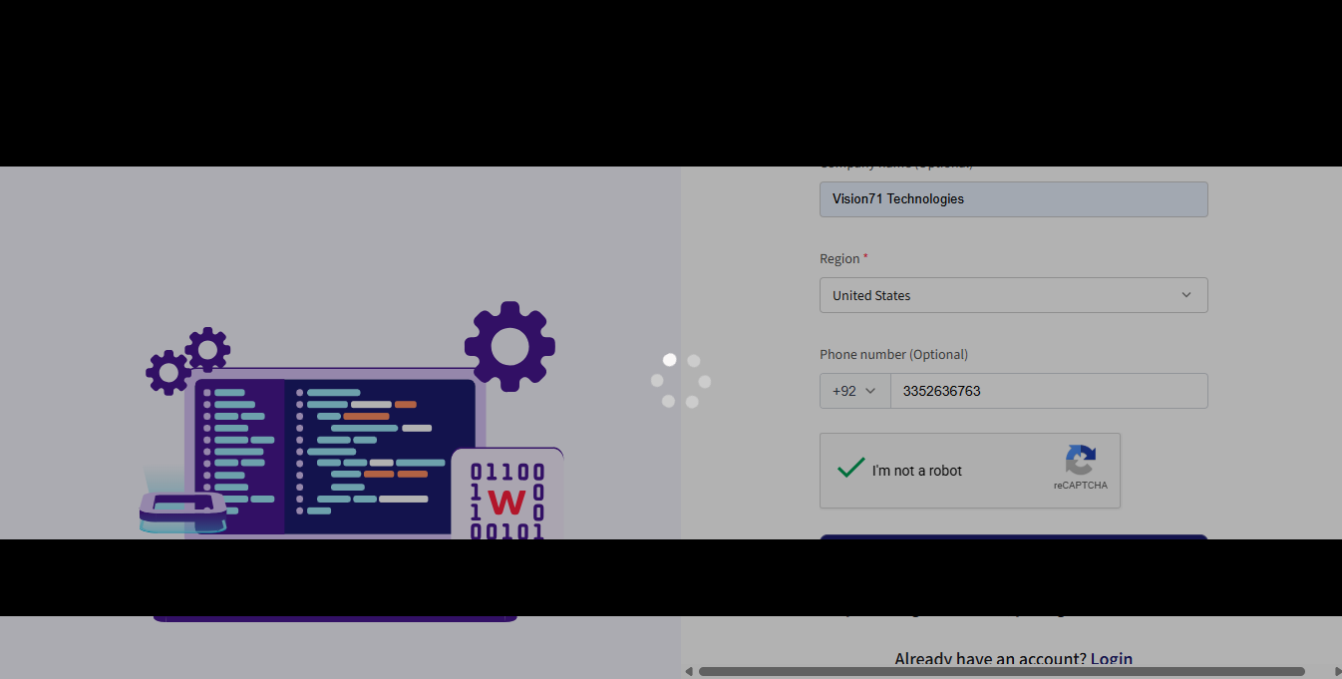
Developer account registration was available. Production merchant approval is a separate step.

Screenshot evidence

Figure 5 Worldpay developer dashboard
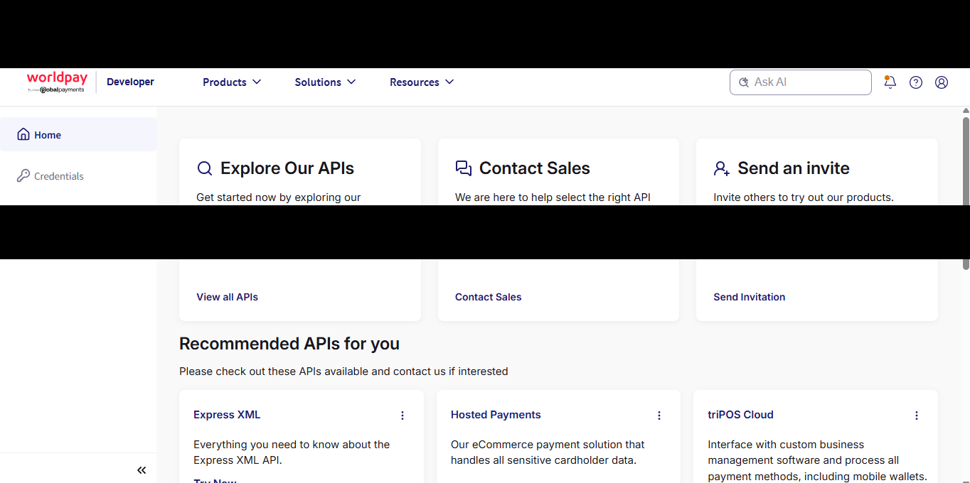
The account provides product discovery and credential routes.

Screenshot evidence

Figure 6 Worldpay product catalogue
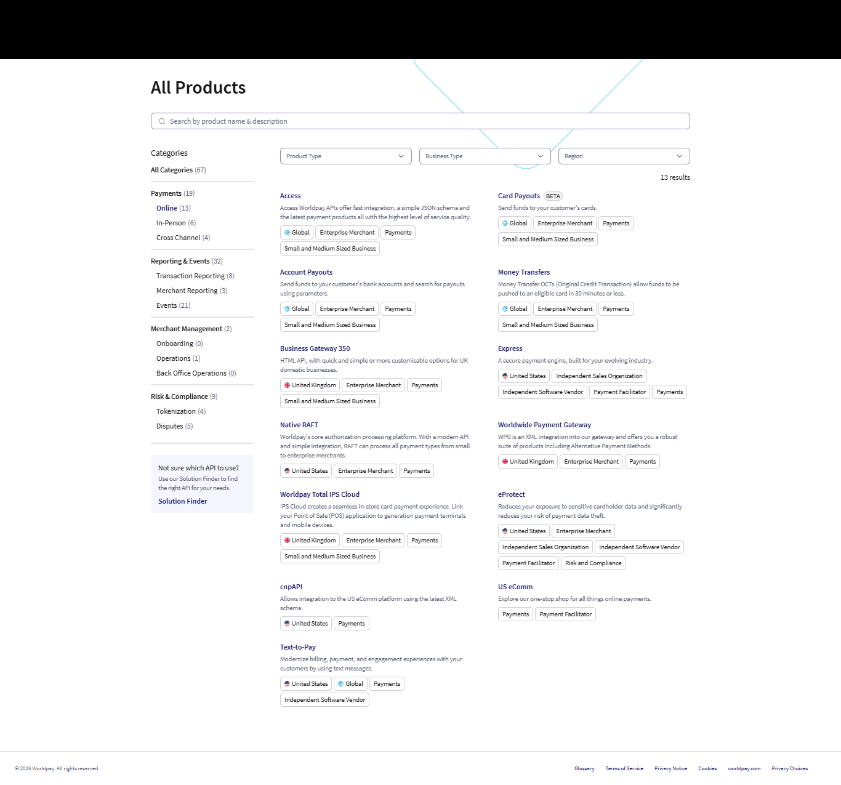
The catalogue illustrates why the exact Worldpay product must be selected before merchant onboarding.

Screenshot evidence

Figure 7 Express and Hosted Payments options
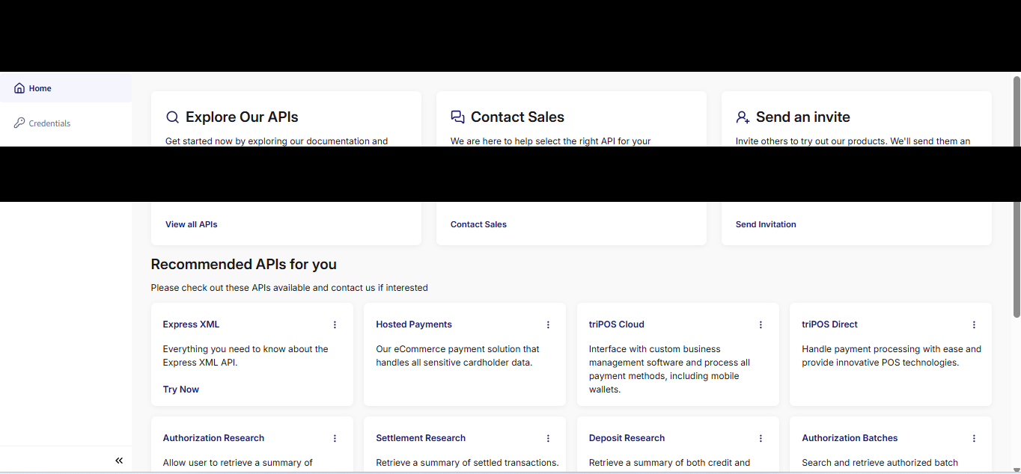
The dashboard includes Express XML and Hosted Payments, the route used for this test.

Figure 8 Registration before checkout
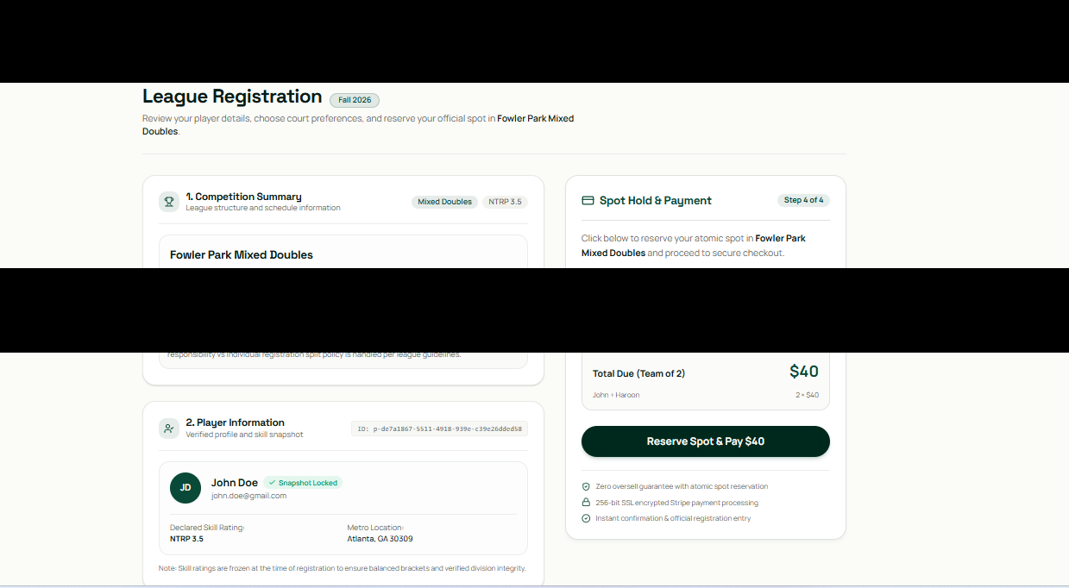
A USD 40 registration was prepared. The captured summary contains a Stripe label. The implemented shared checkout uses provider neutral wording.

Screenshot evidence

Figure 9 Worldpay checkout handoff
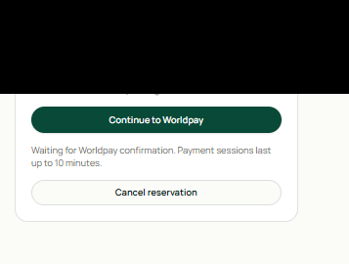
The application offers the hosted checkout and waits for provider confirmation.

Figure 10 Worldpay hosted payment form
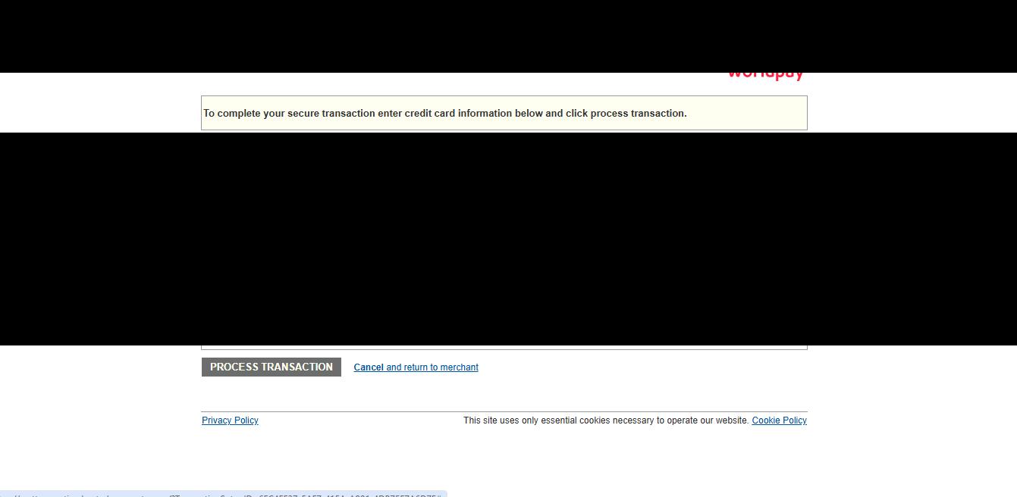
Worldpay collects card details on its hosted payment form. Card input is redacted. Matching Reporting records provide the transaction result.

Screenshot evidence

Figure 11 Processing after return

The return URL and processing screen alone are not payment confirmation evidence.

Figure 12 Confirmed player dashboard
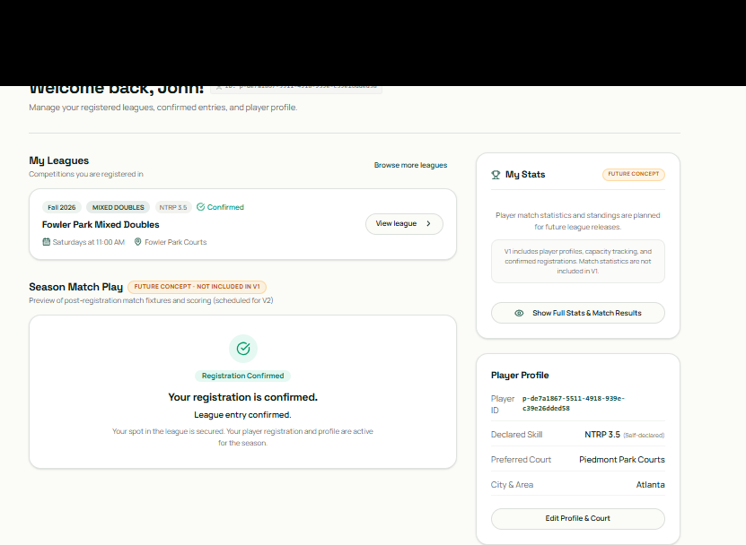
The dashboard shows the player registered for Fowler Park Mixed Doubles.

Screenshot evidence

Figure 13 Registration confirmation
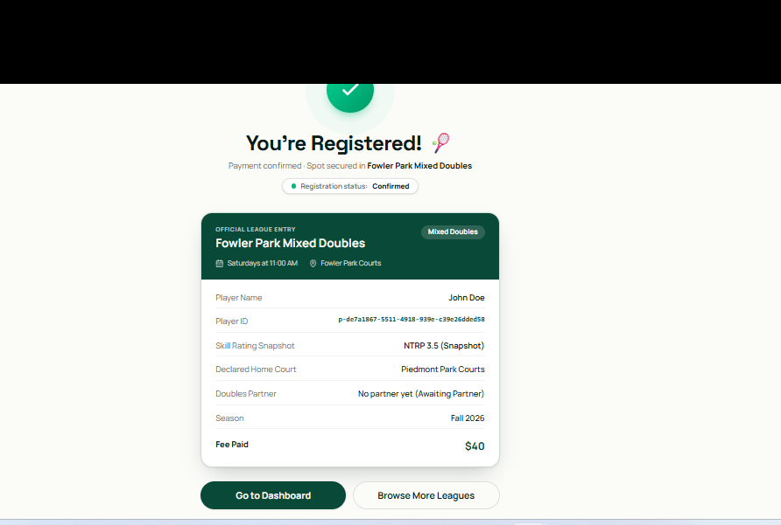
The application shows a USD 40 registration confirmation. Server records provide the stronger payment evidence.

Figure 14 Processing and pending capture
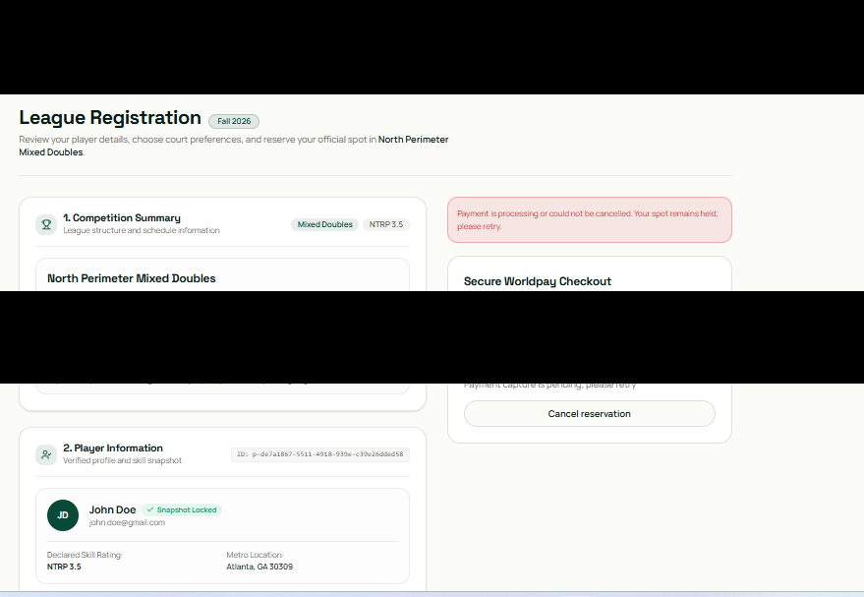
The application retains the reservation while payment processing is unresolved.

Screenshot evidence

Figure 15 Hosted page unavailable
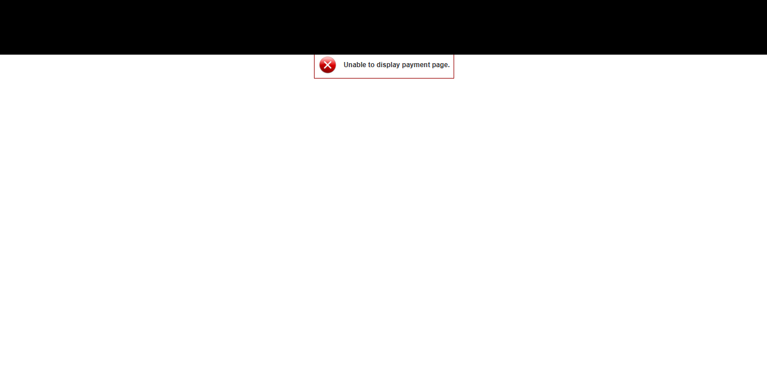
Reopening the page failed. This does not by itself prove duplicate charge or double booking prevention.

Figure 16 Successful registration
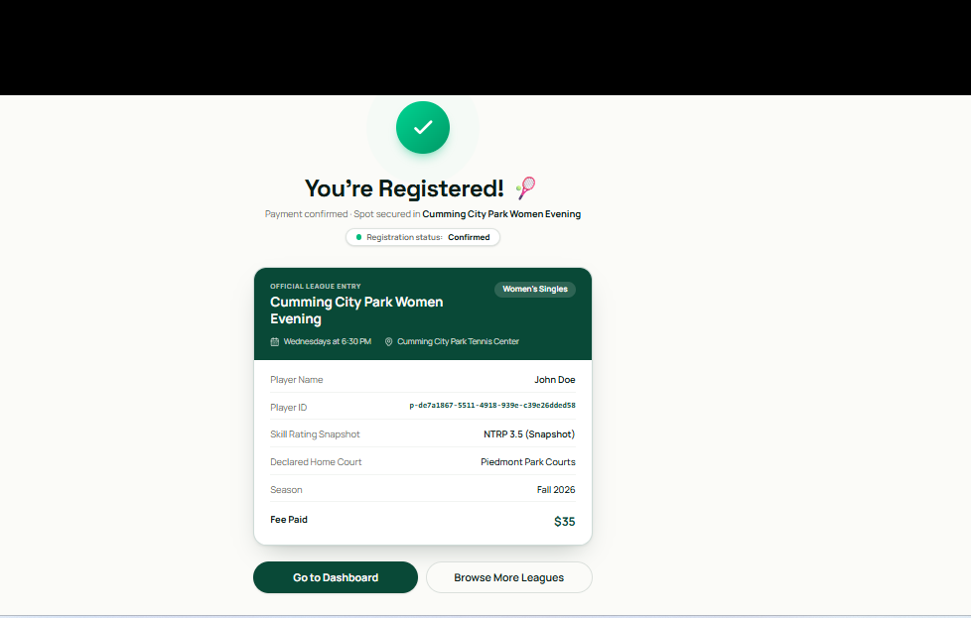
The application shows a USD 35 registration. The matching completed authorization is recorded in the server evidence.

Browser payment workflow

Figure 17 Null Processor reference
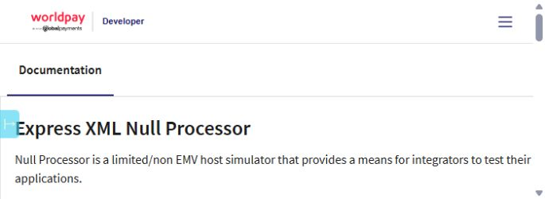
Shows a processor specific reference. It does not establish the authorization decline trigger used here. Full capture: 2026-10-08-01-express-null-rules.png

Figure 18 Abandonment capacity before
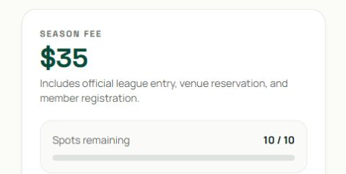
Shows 10 available spots before checkout. It does not prove a provider transaction count. Full capture: 2026-10-08-02-abandon-capacity-before.png

Browser payment workflow

Figure 19 Abandonment pending reservation
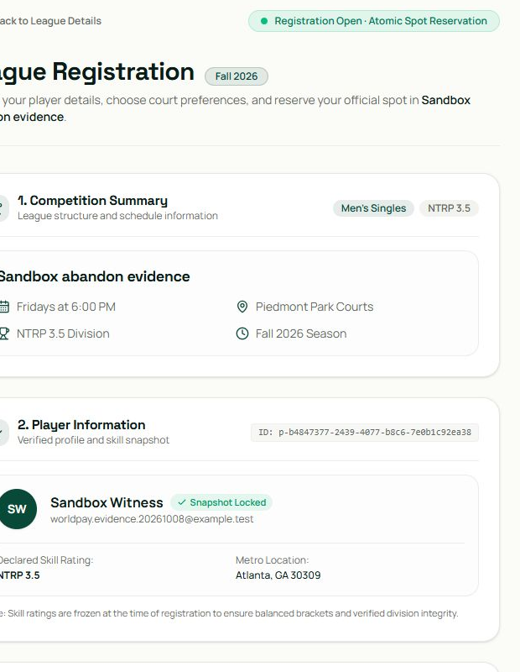
Shows the pending Worldpay handoff. It does not prove payment or expiry. Full capture: 2026-10-08-03-abandon-pending.png

Figure 20 Abandonment hosted form
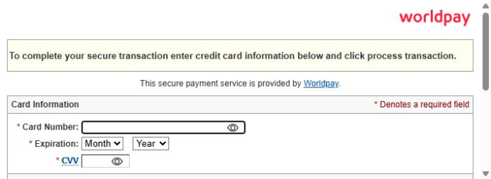
Shows the blank hosted form reached before closing. It does not prove expiry or absence of authorization. Full capture: 2026-10-08-04-abandon-hosted-empty.png

Browser payment workflow

Figure 21 Double click creation state
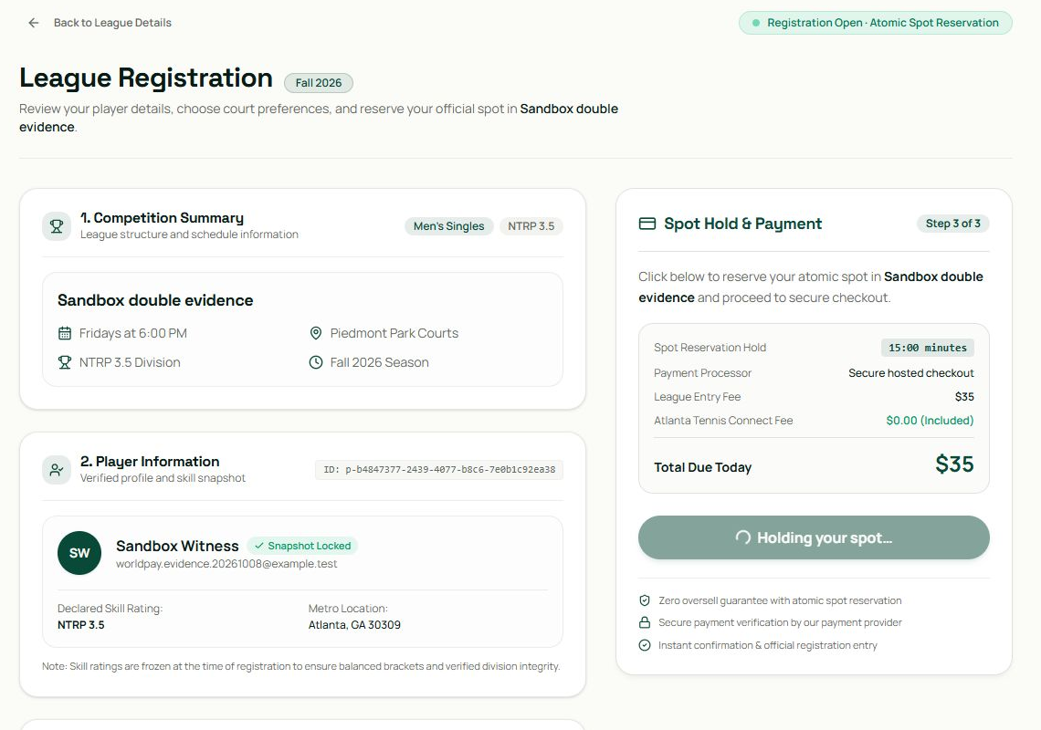
Shows the disabled button after the double click. It does not independently prove charge counts. Full capture: 2026-10-08-05-double-click.png

Figure 22 Double click checkout result
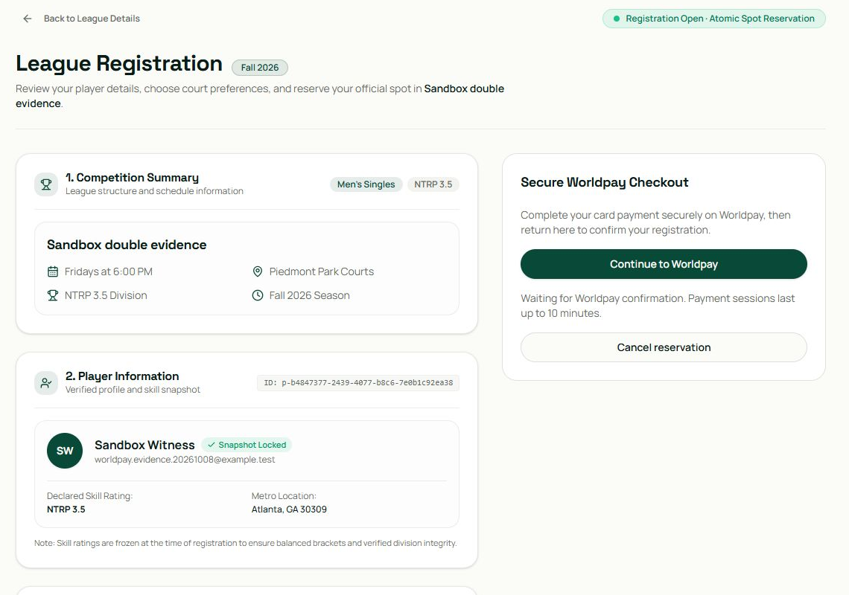
Shows one pending checkout in the app. Saved server counts establish one setup; this is not a portal audit. Full capture: 2026-10-08-06-double-checkout.png

Browser payment workflow

Figure 23 Abandonment capacity after
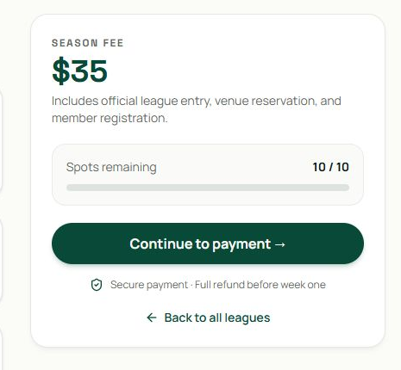
Shows capacity restored to 10 after reconciliation. It does not prove release exactly at the hold deadline. Full capture: 2026-10-09-07-abandon-capacity-after.png

Figure 24 Abandonment dashboard
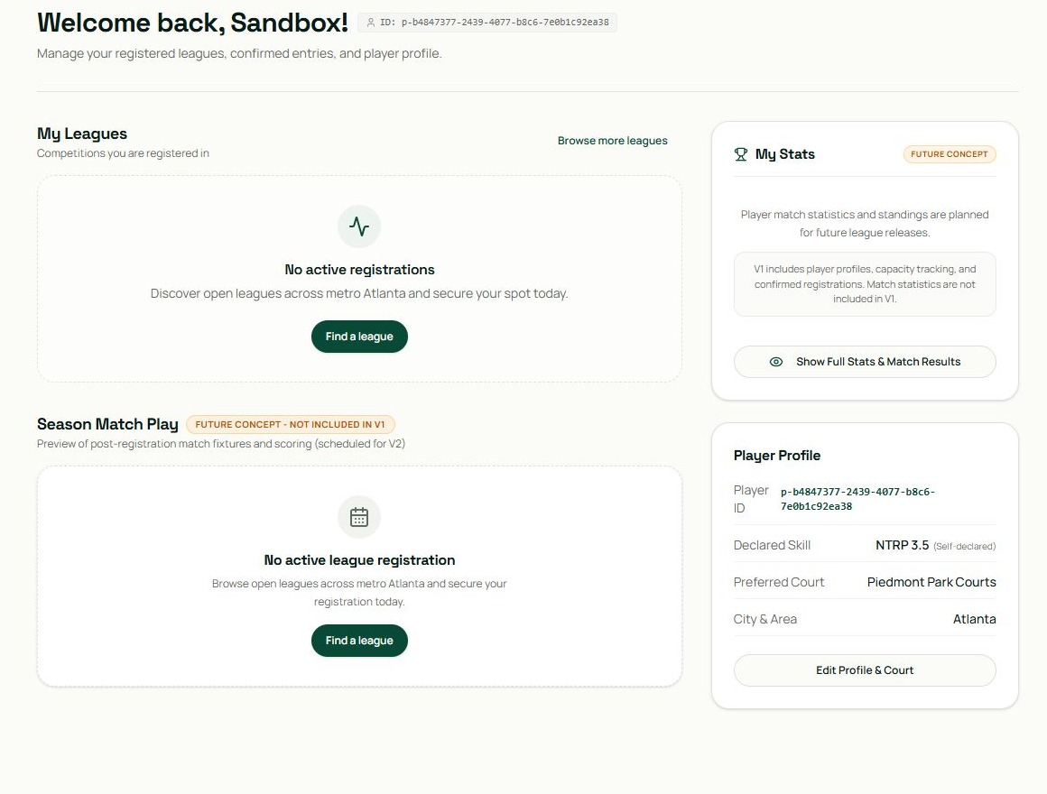
Shows no confirmed registration for the test user at that time. Reporting supplies the no authorization evidence. Full capture: 2026-10-09-08-abandon-dashboard.png

Browser payment workflow

Figure 25 Express return and Reporting documentation
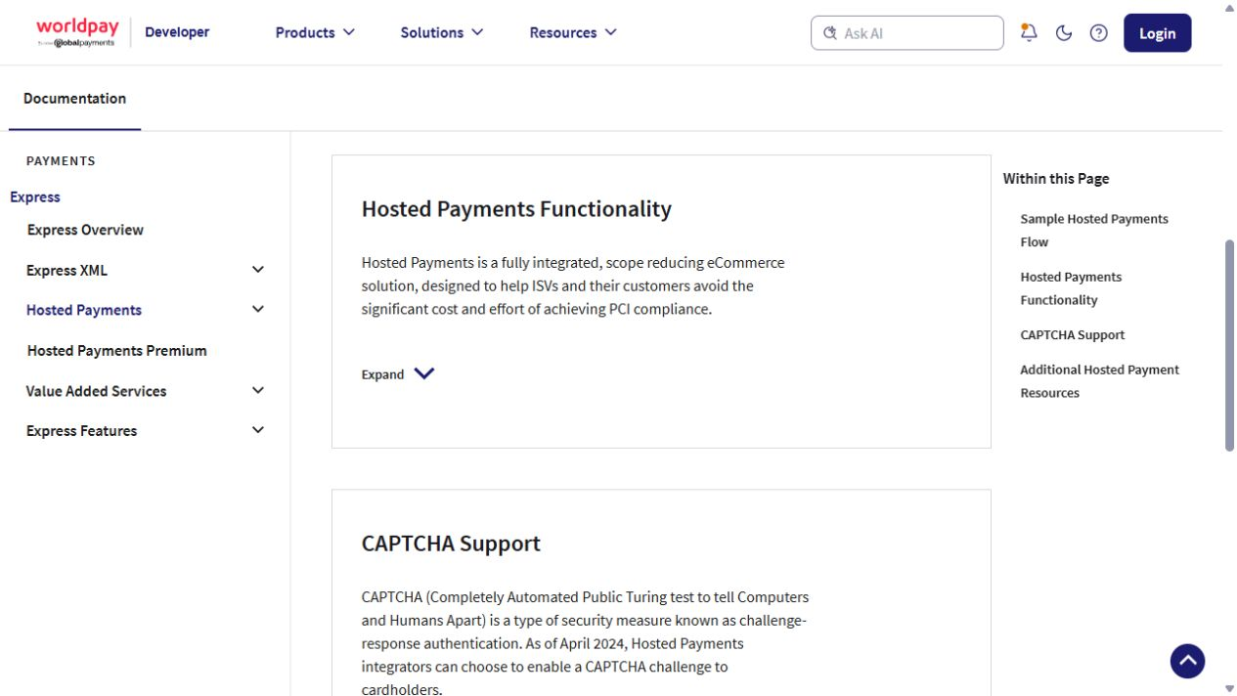
Shows browser return validation and Reporting guidance. It does not prove that every optional notification product is unavailable. Full capture: 2026-10-09-09-express-return-reporting.png

Figure 26 Access Events provisioning
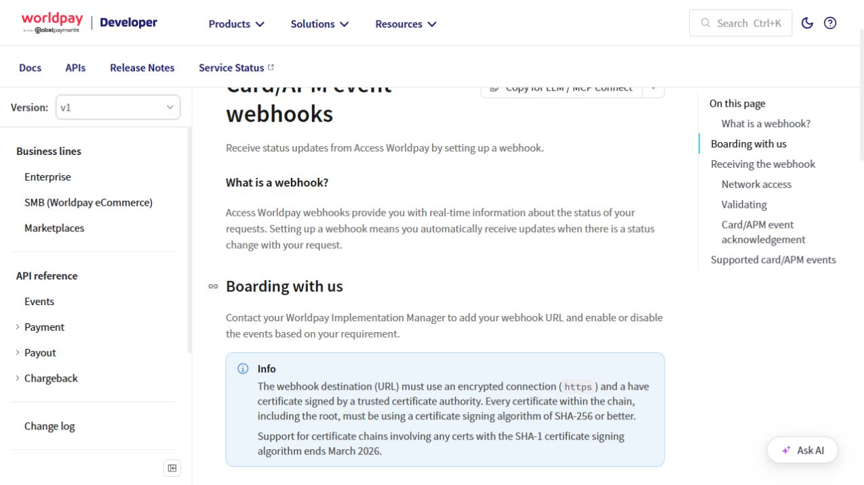
Shows implementation manager provisioning for Access Events. It does not establish Express credential compatibility. Full capture: 2026-10-09-10-access-events.png

Browser payment workflow

Figure 27 Controlled decline capacity before
Shows 10 spots before the fee was configured for the decline test. It does not prove a charge outcome. Full capture: 2026-10-09-decline-01-capacity-before.png

Figure 28 Controlled decline hosted result
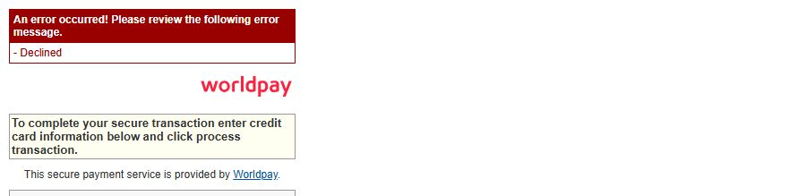
Shows the actual Declined banner with card fields excluded. It does not prove app capacity release by itself. Full capture: 2026-10-09-decline-02-hosted-result.png

Browser payment workflow

Figure 29 Controlled decline app state
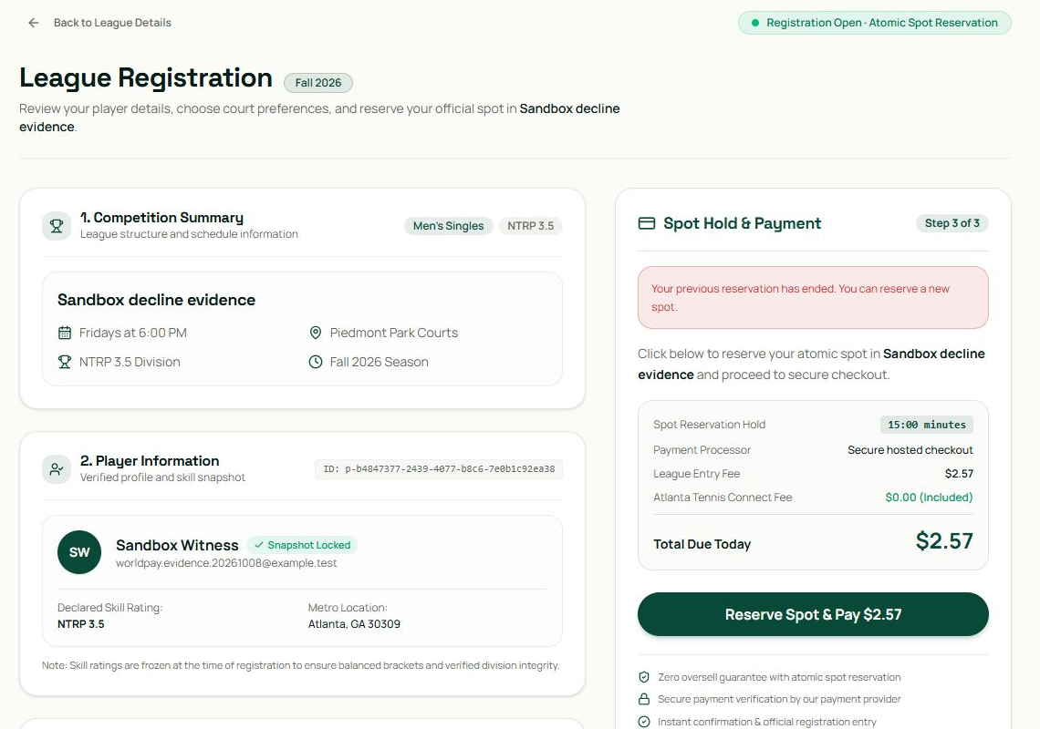
Shows that the reservation ended and was not confirmed. Reporting and server records establish its failed state. Full capture: 2026-10-09-decline-03-app-state.png

Figure 30 Controlled decline capacity after
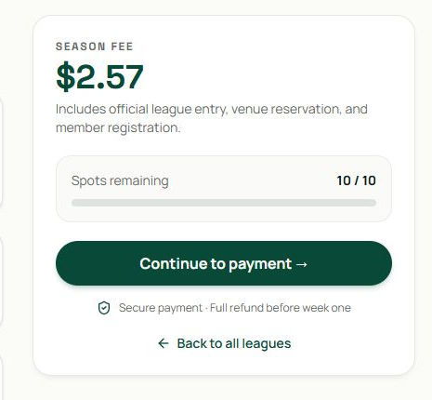
Shows capacity restored to 10. It does not replace the saved zero capture count. Full capture: 2026-10-09-decline-04-capacity-after.png

Browser payment workflow

Figure 31 Success sequence 1 reservation
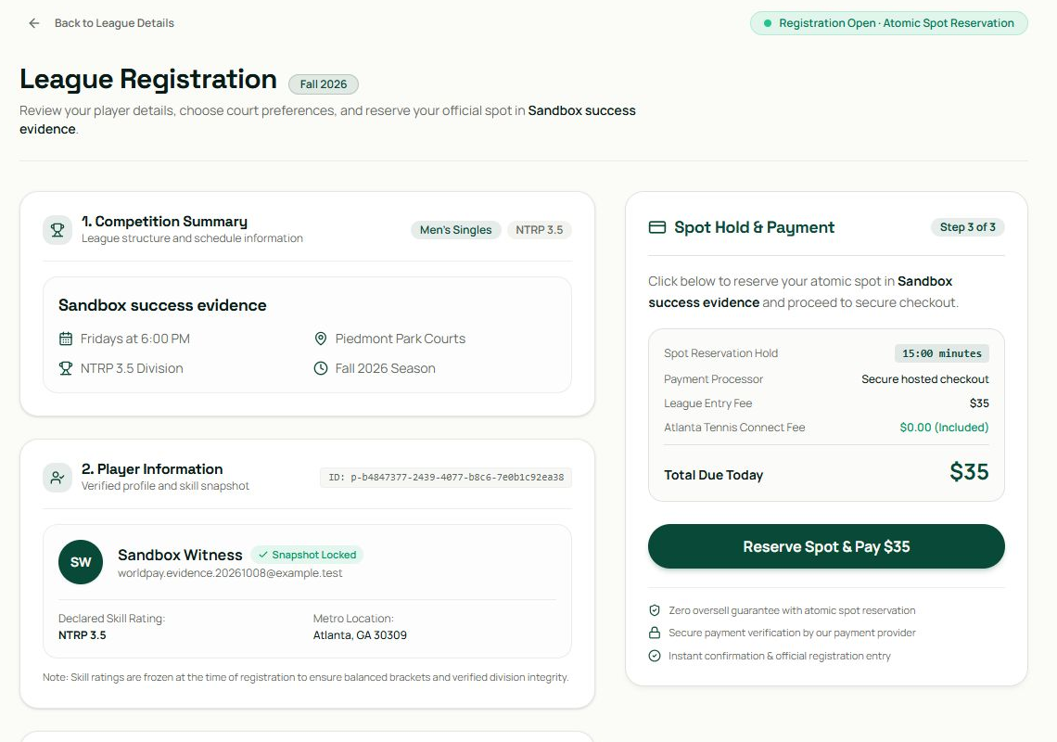
Shows the 35 dollar registration before payment. It does not prove a charge. Full capture: 2026-10-09-success-01-reservation.png

Figure 32 Success sequence 2 hosted checkout
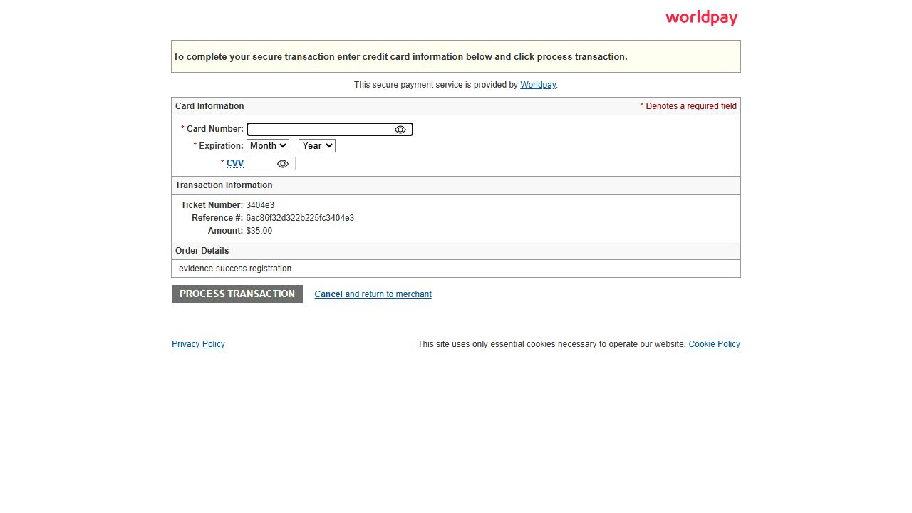
Shows the blank Worldpay hosted form and order reference. It does not prove approval. Full capture: 2026-10-09-success-02-hosted.png

Browser payment workflow

Figure 33 Success sequence 3 return loading
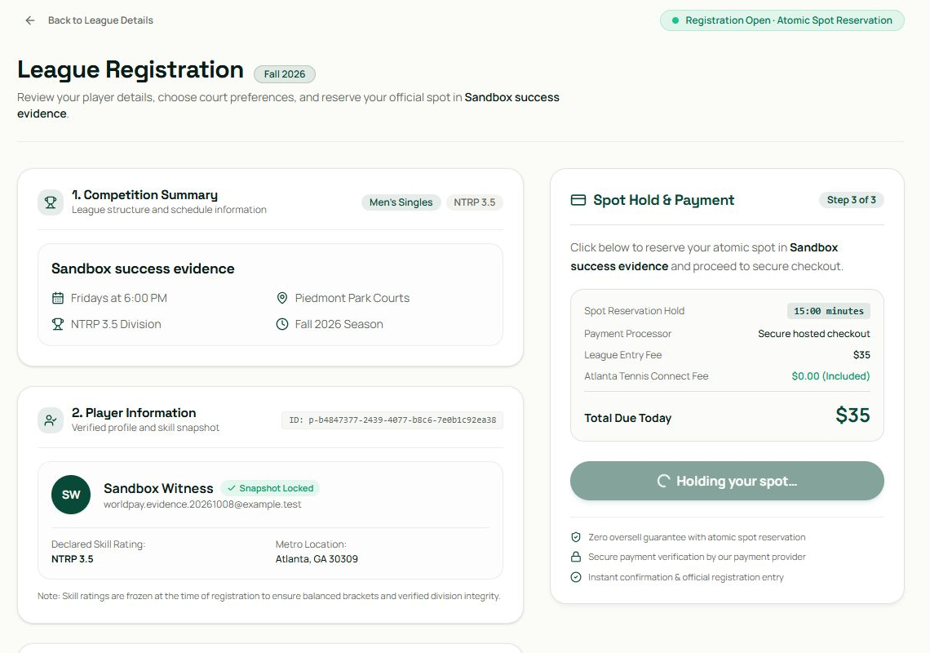
Shows the app reloading after provider processing. It does not prove payment confirmation. Full capture: 2026-10-09-success-03-processing.png

Figure 34 Success sequence 4 confirmation
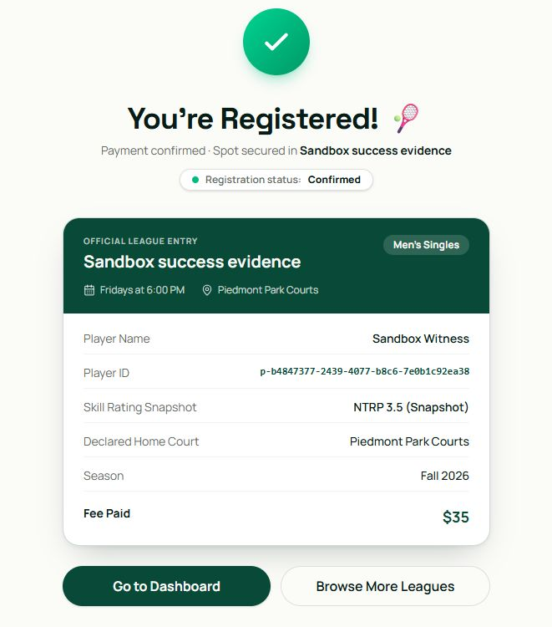
Shows the app confirmed entry. Reporting independently records one approved capture; this screen does not prove settlement. Full capture: 2026-10-09-success-04-confirmation.png

Browser payment workflow

Figure 35 Success sequence 5 dashboard
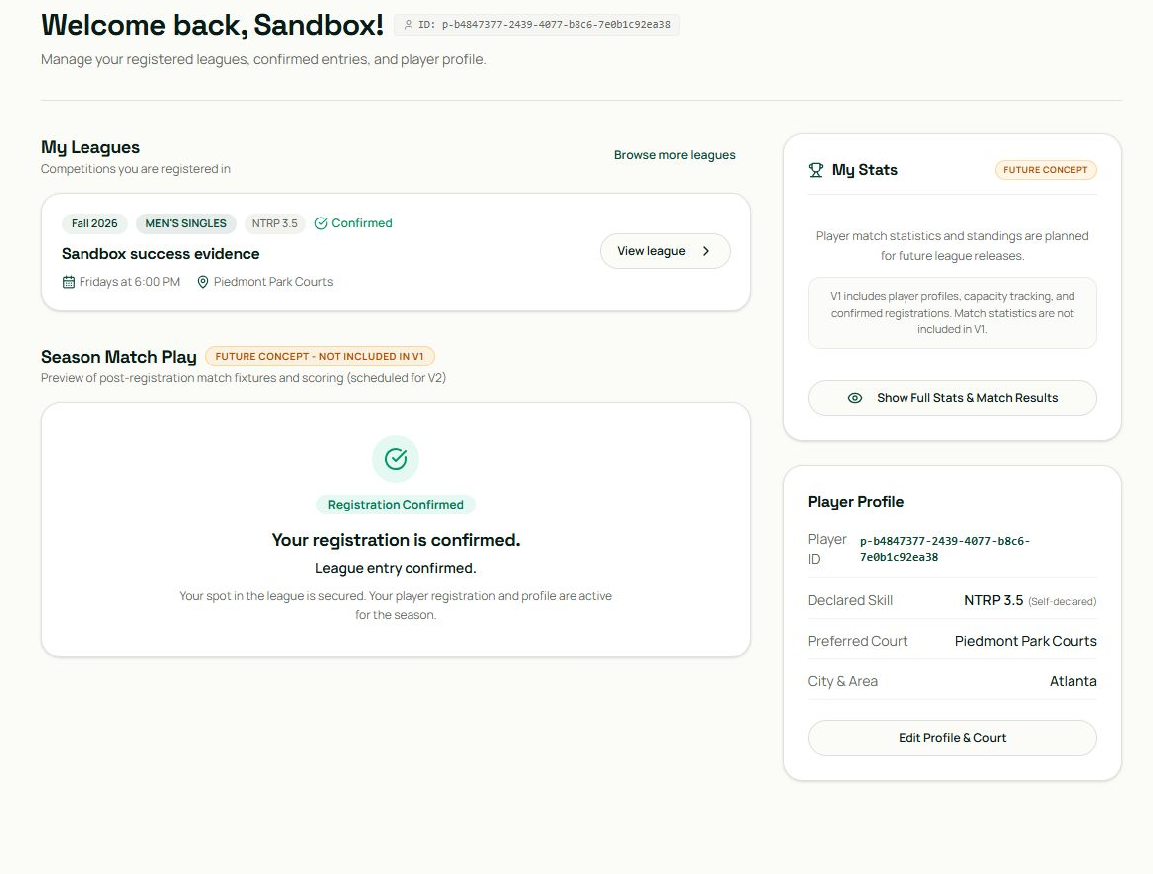
Shows one confirmed league entry for the test user. It does not prove portal completeness or bank settlement. Full capture: 2026-10-09-success-05-dashboard.png

Figure 36 Confirmation after refresh
Shows the same confirmed entry after refresh. Saved replay counts, not the image alone, prove unchanged registration and capture counts. Full capture: 2026-10-09-success-refresh.png

Browser payment workflow

Figure 37 Confirmed registration after refresh
Shows a confirmed registration during an application refresh. The matching provider capture is recorded separately. Full capture: 2026-10-09-success-after-fix-refresh.png

